
M. S. RAMAIAH UNIVERSITY OF APPLIED SCIENCES
Ramaiah School of Public Health
Curriculum Overlap Analysis
Master of Public Health (MPH) & Master in Hospital Administration (MHA)
Mapping of Common Teaching Courses, Course Contents & Shared-Class Delivery
Batch 2022 · Programme Codes 097 (MPH) & 098 (MHA)
Scope: theory / teaching courses (project work, dissertation, internship & hospital training excluded)

Contents
1. Purpose and Scope 3
2. Programmes at a Glance 3
3. Full Course Structure of Each Programme 4
3.1 MPH (097) - Semester-wise Scheme 4
3.2 MHA (098) - Semester-wise Scheme 5
4. Overlap Summary 7
5. Strongly Overlapping Courses (Detailed Content Mapping) 8
6. Partially Overlapping Courses (Detailed Content Mapping) 11
7. Elective-level Overlaps 13
8. Courses Unique to Each Programme 13
9. Organising Common Classes - Suggested Course Leaders & Subject Experts 15
10. Key Observations and Recommendations 16

1. Purpose and Scope
This report maps and highlights the overlapping course content between the Master of Public Health (MPH, Programme Code 097) and the Master in Hospital Administration (MHA, Programme Code 098), both offered by the Faculty of Life and Allied Health Sciences, M. S. Ramaiah University of Applied Sciences, for Batch 2022.
As requested, the analysis is confined to teaching (theory) courses. Project work, dissertation, internship and hospital / practical training are excluded from the overlap mapping, since these are experiential rather than taught components.
For each pair of overlapping courses the report gives the course code and title in both programmes, the degree of overlap, the specific common content (mapped topic-by-topic against the approved Course Specifications), and the key difference in emphasis. A dedicated section then recommends how the common courses could be run as shared classes, and which internal course leaders and external subject experts could deliver them.

At a glance
8  Common teaching themes | ~90%  Peak course overlap | 80 / 82  MPH / MHA credits | 8  Courses for shared classes

2. Programmes at a Glance
Parameter | MPH (097) | MHA (098)
Award | Master of Public Health | Master in Hospital Administration
Duration/mode | 2 years, full-time | 2 years, full-time
Total credits | 80 | 82
Core (taught) courses | ≈ 15 theory courses | ≈ 13 theory courses
Orientation | Population / public health | Hospital/healthcare administration
Experiential (excluded) | Project work, Dissertation, Internship | Hospital training, Project, Dissertation, Internship

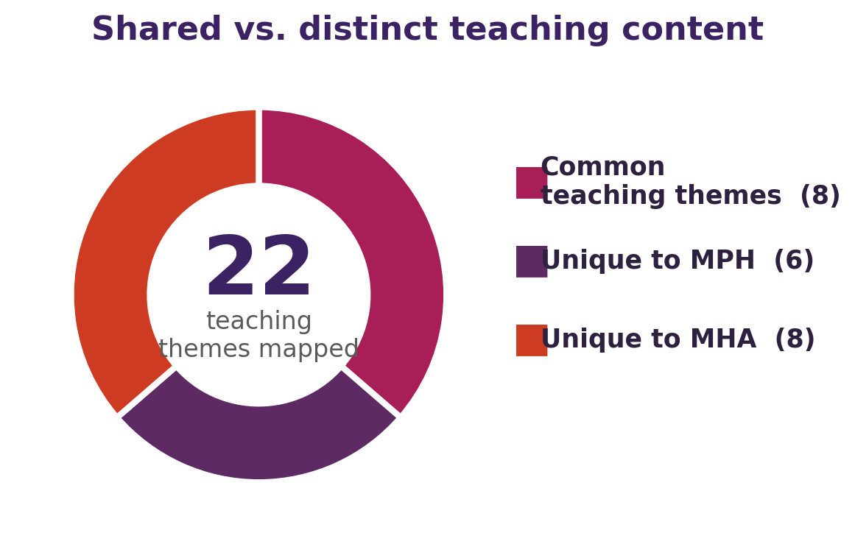
Figure 1. Of the taught content, 8 themes are common to both programmes while each retains a distinct set of courses.

3. Full Course Structure of Each Programme

3.1 MPH (097) - Semester-wise Scheme
Code | Course Title | Cr.
Semester I (20 credits)
PHC501A | Principles and Practice of Public Health | 3
PHC502A | Public Health Systems & Health Policy | 4
PHC503A | Epidemiology | 3
PHC504B | Healthcare Management and Leadership | 4
PHC505A | Biostatistics | 4
PHO501A | Open/Generic Elective – 1 (O/GEC-1) | 2
Semester II (20 credits)
PHC506A | Public Health Priorities in India-I (Communicable Diseases) | 4
PHC507A | Public Health Priorities in India-II (NCDs & Nutrition) | 4
PHC508A | Research Methodology in Public Health | 4
PHC509A | Health Behaviour and Health Promotion | 3
PHC510A | Ethics in Public Health | 2
PHE5XXA | Major Discipline Elective – 1 (MDEC-1) | 3
Semester III (21 credits)
PHC601A | Global Health | 2
PHC602A | Technology in Public Health | 3
PHC603A | Programme Planning and Evaluation | 3
PHC604A | Demography and Population Sciences | 2
PHP605A | Project Work † | 5
PHE6XXA | Major Discipline Elective – 2 (MDEC-2) | 3
PHP606A | Dissertation – Part 1 † | 3
Semester IV (19 credits)
PHE6XXA | Major Discipline Elective – 3 (MDEC-3) | 3
PHOXXA | Open/Generic Elective – 2 (O/GEC-2) | 3
PHP607A | Dissertation – Part 2 † | 7
PHI608A | Internship † | 6
† Experiential component - excluded from overlap mapping.

MPH major-discipline & open electives
- PHE501A Qualitative Research Methods
- Environment and Health
- Health Economics
- PHE601A Implementation Science (Health Programme Design, Planning & Implementation)
- PHE602A Evidence Synthesis (Systematic Review & Meta-analysis)
- Population Microbiology

3.2 MHA (098) - Semester-wise Scheme
Code | Course Title | Cr.
Semester I (20 credits)
HAC501C | Organizational Behavior & Fundamentals of Management in Healthcare | 3
HAC502C | Accounting and Financial Management in Healthcare | 3
HAC503C | Human Resource Management in Healthcare | 2
HAC504C | Epidemiology and Public Health Administration | 3
HAC505C | Management of Clinical and Non-Clinical Services | 3
HAOXXXA | Open/Generic Elective – 1 (O/GEC-1) | 2
HAL507C | Hospital / Practical Training – 1 † | 4
Semester II (20 credits)
HAC508C | Hospital Planning and Designing | 4
HAC509C | Quality Management in Healthcare | 3
HAC510C | Healthcare Management and Leadership | 3
HAC511C | Biostatistics and Research Methodology | 4
HAE5XXA | Major Discipline Elective – 1 (MDEC-1) | 2
HAL513C | Hospital / Practical Training – 2 † | 4
Semester III (22 credits)
HAC601C | Legal Aspects and Ethics in Healthcare | 3
HAC602C | Healthcare Analytics and Operational Research | 3
HAC603C | Marketing and Strategy Management in Healthcare | 4
HAE6XXA | Major Discipline Elective – 2 (MDEC-2) | 2
HAP605C | Project Work † | 6
HAL606C | Hospital / Practical Training – 3 † | 4
Semester IV (20 credits)
HAOXXXA | Open/Generic Elective – 2 (O/GEC-2) | 2
HAI608C | Internship † | 8
HAP609C | Dissertation † | 10
† Experiential component - excluded from overlap mapping. MHA totals: 82 credits (20 + 20 + 22 + 20) and 2,200 marks across four semesters.

MHA discipline & open electives
- HAE512A Project Management
- HAE514A Patient Safety
- HAE517A Advanced Bio-statistics in Health Sciences
- HAE518A Healthcare Costing and Health Financing
- HAE604A Entrepreneurship in Healthcare
- HAE605A Technology in Healthcare
- HAE606A NABH / NMC Training
- HAE607A Health Informatics
- HAE608A Health Programme Design, Planning, Implementation
- HAE610A Evidenced-based Healthcare

4. Overlap Summary
The chart below ranks the common teaching themes by the estimated degree of content overlap; the table lists the matching courses in each programme.
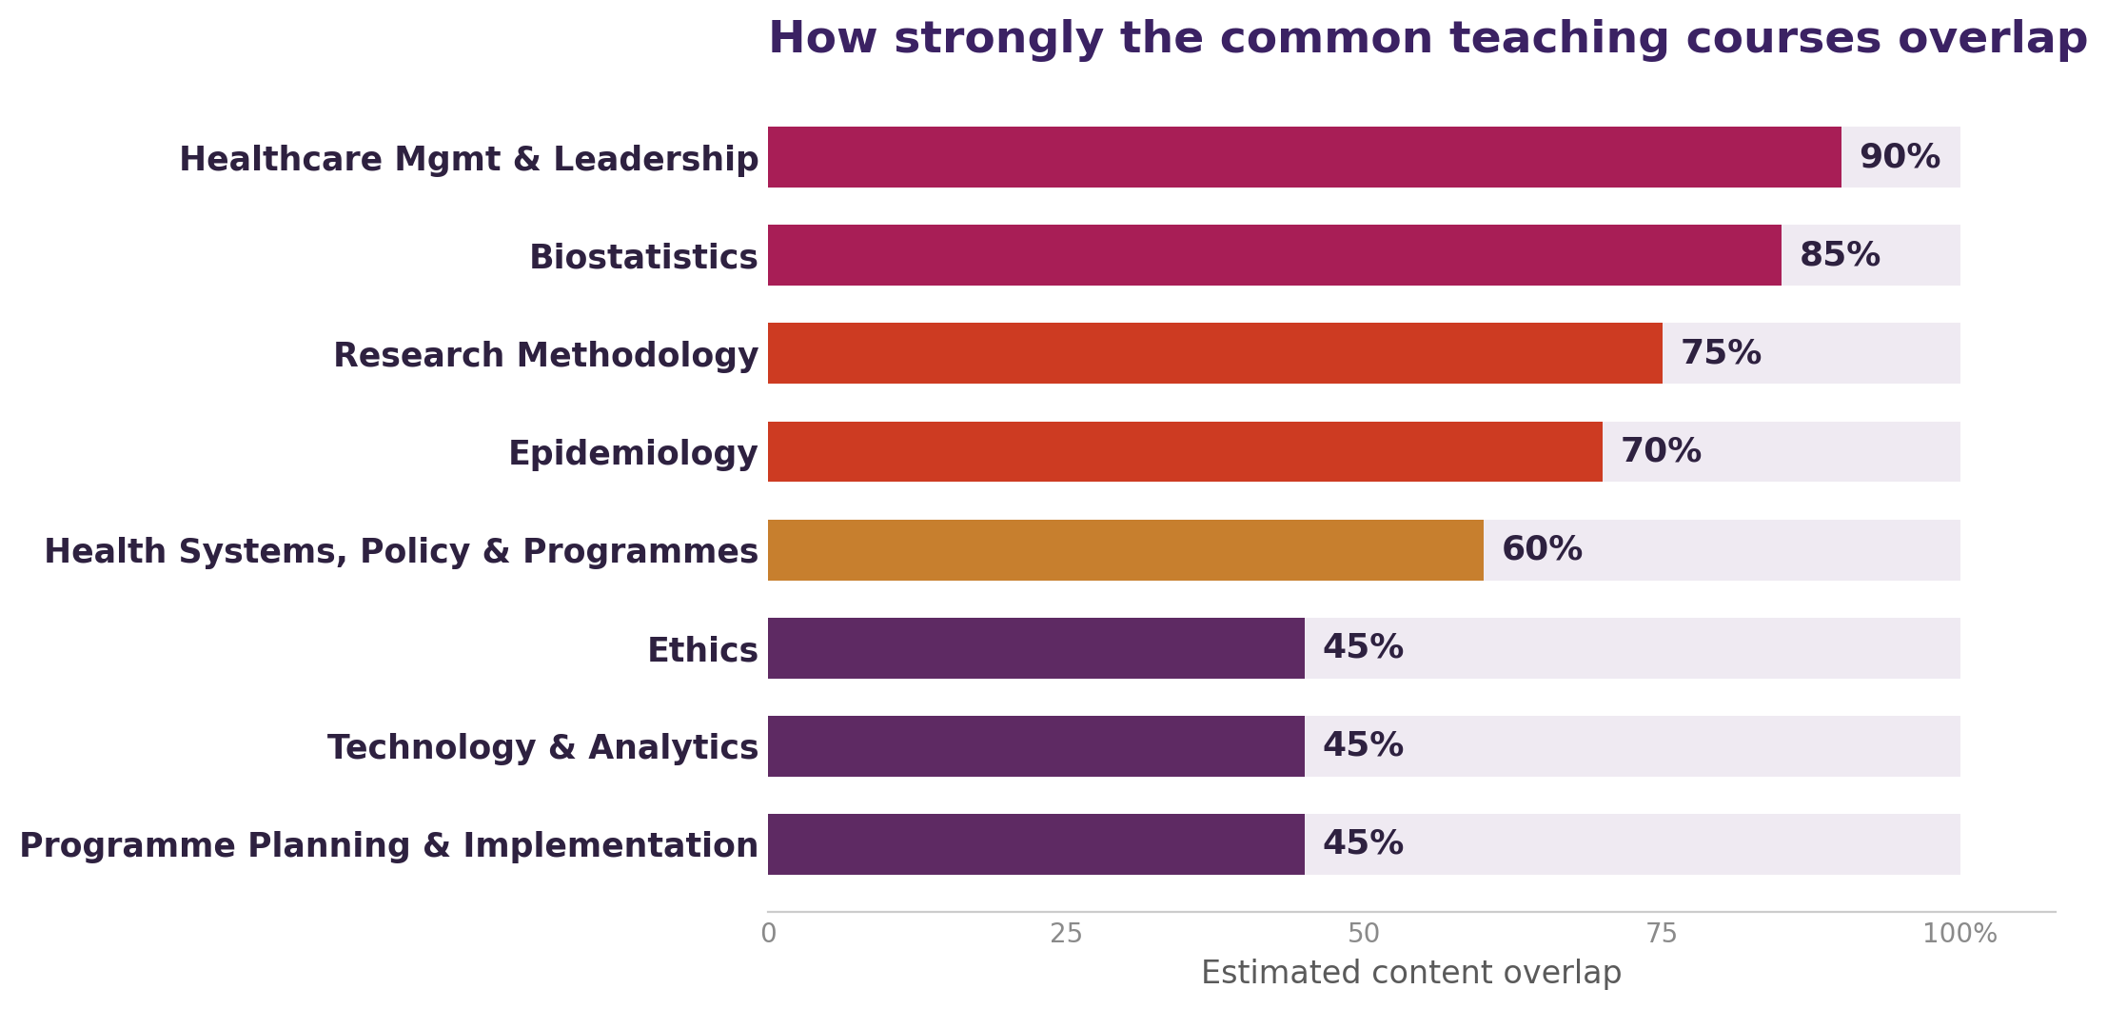
Figure 2. Estimated content overlap of the eight common teaching themes.
Overlapping theme | MPH course | MHA course
Healthcare Management & Leadership (Very High (~90%)) | PHC504B - Healthcare Management and Leadership | HAC510C - Healthcare Management and Leadership
Biostatistics (Very High (~85%)) | PHC505A - Biostatistics | HAC511C - Biostatistics and Research Methodology (biostatistics component)
Research Methodology (High (~75%)) | PHC508A - Research Methodology in Public Health | HAC511C - Biostatistics and Research Methodology (research-methodology component)
Epidemiology (High (~70%)) | PHC503A - Epidemiology | HAC504C - Epidemiology and Public Health Administration (epidemiology component)
Health Systems, Policy & National Programmes (Moderate–High) | PHC502A - Public Health Systems & Health Policy (and parts of PHC501A) | HAC504C - Epidemiology and Public Health Administration (Units 3–6)
Ethics (Moderate) | PHC510A - Ethics in Public Health | HAC601C - Legal Aspects and Ethics in Healthcare (ethics component)
Technology, Health Informatics & Analytics (Moderate) | PHC602A - Technology in Public Health | HAC602C - Healthcare Analytics & Operational Research; electives HAE605A Technology in Healthcare, HAE607A Health Informatics
Programme / Health-Service Planning & Implementation (Moderate) | PHC603A - Programme Planning and Evaluation; PHE601A - Implementation Science | Elective HAE608A - Health Programme Design, Planning, Implementation

5. Strongly Overlapping Courses (Detailed Content Mapping)
These courses share the same or near-identical taught content. They are the strongest candidates for shared teaching, common course material, or credit recognition between the two programmes.
Healthcare Management & Leadership
MPH course | PHC504B - Healthcare Management and Leadership
MHA course | HAC510C - Healthcare Management and Leadership
Overlap | Very High (~90%)
Common content | Organization & organizational behaviour (structure, culture, climate, team dynamics, personality); management functions (planning, organizing, staffing, directing, coordinating, budgeting); leadership concepts, roles and traits; leadership theories (Great Man, Trait, Contingency, Situational, Behavioural); motivation theories (Maslow, Herzberg, intrinsic vs extrinsic); leadership models (Ruth-Seliger, Maxwell, Bagchi's platform vs purpose, sources of power); conflict management; leadership challenges & change management.
Key difference | MPH frames delivery around public-health programmes/health systems; MHA frames the same content around hospital administration and the healthcare/VUCA context. Course titles are identical.

Biostatistics
MPH course | PHC505A - Biostatistics
MHA course | HAC511C - Biostatistics and Research Methodology (biostatistics component)
Overlap | Very High (~85%)
Common content | Definition/scope of statistics; data types & scales of measurement; construction of scales; reliability & validity; tabulation & graphical presentation; descriptive statistics (central tendency & dispersion); probability & distributions; sample-size estimation; probabilistic sampling (simple random, systematic, stratified, cluster) and non-probabilistic sampling (convenience, quota, purposive, snowball); inferential statistics - hypothesis testing, p-value, confidence intervals; Pearson's & Spearman's correlation; linear & logistic (binary/multinomial) regression.
Key difference | Wording is near-verbatim across both programmes. MHA additionally binds research-methodology units into the same course; MPH teaches Research Methodology as a separate course (PHC508A).

Research Methodology
MPH course | PHC508A - Research Methodology in Public Health
MHA course | HAC511C - Biostatistics and Research Methodology (research-methodology component)
Overlap | High (~75%)
Common content | Meaning & types of research; steps in conducting research; research problem, objectives & hypothesis formulation; literature review; research methods & methodology; sample size & sampling technique; data collection tools; research ethics; proposal, report writing & dissemination of results/referencing.
Key difference | MPH is broader - dedicated units on qualitative & mixed-methods designs, research paradigms (ontology/epistemology), PRISMA and trustworthiness. MHA covers the core research process at an applied hospital level.

Epidemiology
MPH course | PHC503A - Epidemiology
MHA course | HAC504C - Epidemiology and Public Health Administration (epidemiology component)
Overlap | High (~70%)
Common content | Scope of epidemiology; measures of disease frequency & association; study designs - ecological/geographical, case-control, cohort, intervention & randomized controlled trials; random error/chance; bias; confounding; interaction & effect modification; association & causation; validity & reliability; screening; natural history of disease; concept of health & disease.
Key difference | MPH extends into advanced epidemiology (chronic, infectious, nutritional, environmental, psychiatric). MHA extends into public-health administration - health-care delivery system in India, national health programmes, national health policy and international health.

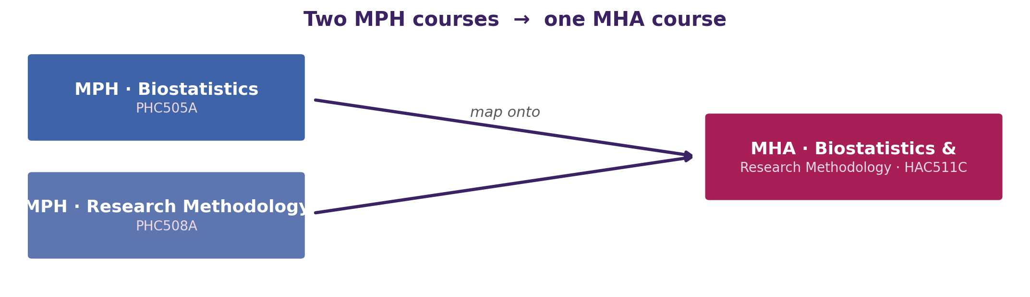
Figure 3. MPH's two quantitative courses map onto MHA's single combined course.

6. Partially Overlapping Courses (Detailed Content Mapping)
These courses share substantial thematic content but differ in emphasis or are packaged differently across the two programmes.
Health Systems, Policy & National Programmes
MPH course | PHC502A - Public Health Systems & Health Policy (and parts of PHC501A)
MHA course | HAC504C - Epidemiology and Public Health Administration (Units 3–6)
Overlap | Moderate–High
Common content | Health-care delivery system in India (Sub-centre, PHC, CHC, HWC, district & tertiary hospitals); organization & administration at national/state/district levels; national health programmes (NHM/NRHM, RCH, Universal Immunization, RNTCP, NACP, NMHP, blindness, malaria, leprosy, iodine); national health policy & five-year plans; international health agencies (WHO, UN, World Bank, UNICEF, UNFPA).
Key difference | MPH treats health-systems frameworks (WHO building blocks, van Olmen), private/NGO sector, CSR and comparative health systems of countries in depth. MHA covers delivery structure and programmes to the extent needed by a hospital administrator.

Ethics
MPH course | PHC510A - Ethics in Public Health
MHA course | HAC601C - Legal Aspects and Ethics in Healthcare (ethics component)
Overlap | Moderate
Common content | Foundations of ethics - theory & principles; organizational influences & ethical implications for health care; ethics of quality, safety & patient care; ethics & technology; priority-setting & resource allocation; professional/moral integrity; social responsibility.
Key difference | MPH is a stand-alone ethics course (community & common good, surveillance & privacy, theories of justice). MHA embeds ethics within a predominantly legal/medico-legal course (Acts, medical jurisprudence, consumer protection, negligence, employee & establishment law).

Technology, Health Informatics & Analytics
MPH course | PHC602A - Technology in Public Health
MHA course | HAC602C - Healthcare Analytics & Operational Research; electives HAE605A Technology in Healthcare, HAE607A Health Informatics
Overlap | Moderate
Common content | Health information systems; EHR/EMR; data → information → knowledge; decision-support systems; health data security, privacy & confidentiality; use of data/analytics in decision-making.
Key difference | MPH emphasizes health-information standards (ICD, SNOMED, DICOM), interoperability, e-Health/mHealth, and Health Information Management practice. MHA emphasizes business analytics (descriptive/predictive/prescriptive), operational research (CPM/PERT, queuing, linear programming) and hospital operations.

Programme / Health-Service Planning & Implementation
MPH course | PHC603A - Programme Planning and Evaluation; PHE601A - Implementation Science
MHA course | Elective HAE608A - Health Programme Design, Planning, Implementation
Overlap | Moderate
Common content | Health-programme planning cycle & approaches; goals, objectives, indicators & targets; monitoring & evaluation (formative, process, terminal, outcome/impact); implementation & assessment; logical framework.
Key difference | MPH offers this as core + a dedicated implementation-science elective. MHA offers it as a discipline elective.

7. Elective-level Overlaps
Beyond the core courses, several electives address the same subject in both programmes and could be jointly offered.
Theme | MPH offering | MHA offering | Common focus
Evidence-based practice | PHE602A - Evidence Synthesis (Systematic Review & Meta-analysis) | HAE610A - Evidenced-based Healthcare | Systematic review, evidence synthesis and evidence-informed decision-making.
Health economics / financing | Health Economics (MDEC elective) | HAE518A - Healthcare Costing and Health Financing | Costing, financing and economic evaluation of health services.
Advanced biostatistics | PHC505A - Biostatistics (advanced topics) | HAE517A - Advanced Bio-statistics in Health Sciences | Advanced statistical methods for health-sciences research.
Patient safety & quality | PHC510A - Ethics (Quality, Safety & Patient Care); quality themes | HAE514A - Patient Safety; HAC509C - Quality Management in Healthcare | Patient-safety principles and quality-of-care concepts.

8. Courses Unique to Each Programme
The following taught courses have no meaningful counterpart in the other programme and define each programme's distinct identity.
Unique to MPH (Public Health orientation) | Unique to MHA (Hospital Administration orientation)
PHC501A - Principles and Practice of Public Health (public-health core) | HAC502C - Accounting and Financial Management in Healthcare
PHC506A - Public Health Priorities in India-I (Communicable Diseases) | HAC503C - Human Resource Management in Healthcare
PHC507A - Public Health Priorities in India-II (NCDs & Nutrition) | HAC505C - Management of Clinical and Non-Clinical Services
PHC509A - Health Behaviour and Health Promotion | HAC508C - Hospital Planning and Designing
PHC601A - Global Health | HAC509C - Quality Management in Healthcare
PHC604A - Demography and Population Sciences | HAC603C - Marketing and Strategy Management in Healthcare
Electives: Qualitative Research Methods, Environment and Health, Population Microbiology | HAC601C - Legal Aspects (legal / medico-legal component)
 | Electives: Project Management, NABH/NMC Training, Entrepreneurship in Healthcare

9. Organising Common Classes - Suggested Course Leaders & Subject Experts
Because the courses below carry the same or nearly the same content in both programmes, they can be run as combined classes for the MPH and MHA cohorts together. For each, a suitable course leader / subject expert is suggested - including the kind of external expert the University could invite to lead a shared class.
Common course | Internal course leader | Suggested external subject expert | Delivery mode
Healthcare Management & Leadership PHC504B ↔ HAC510C | Faculty of Management & Commerce (healthcare-management stream); Department of Hospital Administration | Senior hospital administrator / CEO; healthcare-leadership faculty from a business school; a management consultant in the health sector | Single combined class - content is near-identical
Biostatistics PHC505A ↔ HAC511C | Biostatistics / Statistics faculty; Department of Community Medicine | Biostatistician from a public-health institute or ICMR centre; statistics faculty from a partner medical college | Single combined class for the statistics component
Research Methodology PHC508A ↔ HAC511C | Public-health research faculty; University research-methodology cell | Senior researcher from ICMR / a public-health foundation; research-methods trainer from a research institute | Combined class; MPH adds qualitative / mixed-methods tutorial
Epidemiology PHC503A ↔ HAC504C | Department of Community Medicine (PSM); public-health / epidemiology faculty | Field epidemiologist (e.g., NIE / India EIS); Community Medicine faculty from a medical college | Combined foundation class; programme-specific extensions after
Health Systems, Policy & National Programmes PHC502A ↔ HAC504C | Health-policy & systems faculty; public-health department | Health-policy specialist from a state health department, PHFI or a health-systems think-tank | Combined lecture series on delivery system & national programmes
Ethics PHC510A ↔ HAC601C | Bioethics / medical-ethics faculty; Institutional Ethics Committee members | Bioethicist from a bioethics centre; a medico-legal / health-law expert | Common ethics module; MHA adds legal / medico-legal sessions
Technology, Informatics & Analytics PHC602A ↔ HAC602C | Health-informatics faculty; Department of Computer Science / Data Science | Health-informatics or health-data-analytics professional from the HealthTech industry | Combined foundation; MPH → standards/HIM, MHA → operations analytics
Programme Planning & Implementation PHC603A ↔ HAE608A | Public-health programme-management faculty | Monitoring & evaluation (M&E) specialist from an NGO / development / public-health programme | Combined elective class on planning, M&E and implementation
Note: the external experts are suggested categories, not named individuals - the University can invite suitable resource persons from partner medical colleges, public-health institutes, business schools and the healthcare industry to lead the shared classes.

10. Key Observations and Recommendations
• Two courses are effectively identical.
Healthcare Management & Leadership (PHC504B / HAC510C) is taught with near-identical units, theories and models in both programmes - the titles are the same. This is the single strongest candidate for a common/shared course.
• A shared quantitative-methods core exists.
Biostatistics (PHC505A) and Research Methodology (PHC508A) in MPH together map almost completely onto the single MHA course Biostatistics & Research Methodology (HAC511C). A common quantitative-methods module could serve both cohorts.
• Epidemiology forms a common foundation.
MPH Epidemiology (PHC503A) and the epidemiology component of MHA's Epidemiology & Public Health Administration (HAC504C) share study designs, measures and biases; the programmes then diverge (advanced epidemiology in MPH vs. health administration in MHA).
• Common classes can draw on shared and external experts.
The eight common themes can be delivered as combined MPH+MHA classes led by a single internal department or an invited external subject expert (see Section 9), improving efficiency and exposing both cohorts to specialists.
• Distinct identities are preserved.
MPH remains population- and community-focused; MHA remains institution-focused (finance, HR, hospital planning, quality, marketing, legal). The overlap is in method and management foundations, not in the programmes' core purpose.
Suggested next steps: (i) run a shared quantitative-methods and management-&-leadership module across MPH and MHA; (ii) hold common foundational lectures in epidemiology, ethics and health systems with programme-specific tutorials; (iii) cross-list the overlapping electives; and (iv) build a panel of internal course leaders and invited external subject experts to deliver the common classes.

Source documents: MPH Programme Specifications 2022 (Approved); MPH Course Specifications 2022 (Approved); Programme Structure and Course Details of MHA 2022–2024 (Approved by the Academic Council, 14 July 2022). Content mapped from the approved Course Specifications of each programme.

